Sprint 3 Review

**Team: Scrum of the Earth**

**GitHub:** [**https://github.com/RMIT-SEPT/majorproject-7-tues-14-30-7**](https://github.com/RMIT-SEPT/majorproject-7-tues-14-30-7)

**REVIEW:**

**The Sprint Goal was:**

* Create a minimum viable product with the ability to log in, view and book with businesses, view a dashboard as a worker, such that all major aspects of the project are functional, and while incorporating CircleCI and Docker under AWS. Past features that require more development will be included in this Sprint.

**Status Overview:**

Sprint 3had 5 new tasks to complete:

* Log in as a user (34)
* Book with a service (20)
* Search for a business (39)
* Modify service details (2)
* Incorporate Docker and CircleCI under AWS

Including tasks from previous Sprints.

Some features have been left while very close to completion, leaving room for flexibility and adjustments in later Sprints.

**Sprint Statistics**

* With a predominantly High or Very High estimated story point value for the tasks of this Sprint, a greater amount of time was required compared to past iterations.

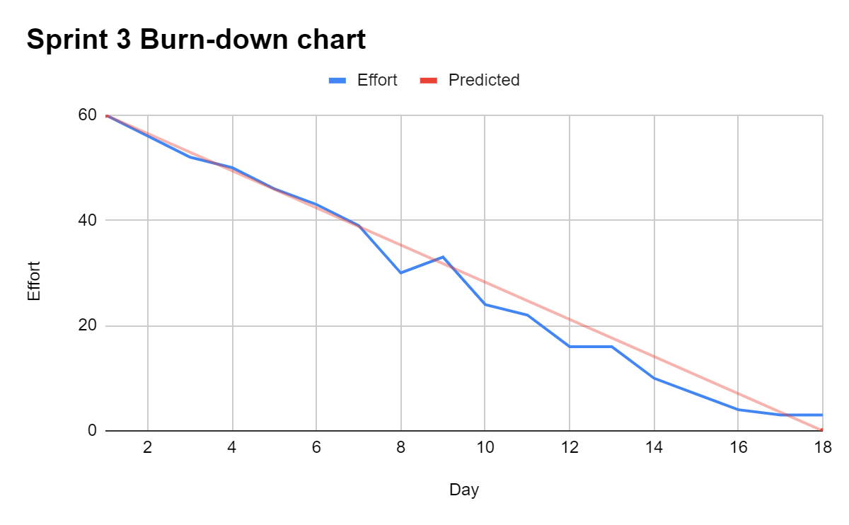

* Despite more challenging tasks, the development team maintained a consistent rate of work, steadily decreasing required effort with a spike between the 8th and 10th day, and a plateau between the 16th and 18th when dockerisation and AWS deployment occurred.